

University of Mumbai

SOLAR POWERED PORTABLE AIR PURIFIER

Submitted in partial fulfillment of the requirements
of the degree of

Bachelor of Engineering
by
Pooja Chavan
Pranali Bhujbal
Anoushka Hazari
Shrikant Raut

Under the Guidance of
Prof. Hemant Jadhav



Department of Electronics and Telecommunications
Vidyalankar Institute of Technology, Wadala (E), Mumbai
2020-2021

CERTIFICATE OF APPROVAL

This is to certify that the project entitled

Solar Powered Portable Air Purifier
is a bonafide work of

Pooja Chavan (Roll No. 18104A2009)

Pranali Bhujbal (Roll No. 18104A2006)
Anoushka Hazari(Roll No. 17104A0034)
Shrikant Raut(Roll No. 17104A0031)

Submitted to the University of Mumbai in partial fulfillment of the requirement for the award of

the

degree of

Undergraduate in “B.E (Electronics and Telecommunication)”.

Guide Head of Department Principal
(Prof.Hemant Jadhav) (Prof. Dr. Sanjay Singh Thakur)

Project Report Approval for Bachelor of Engineering

This project report entitled
by

- Pooja Chavan (Roll No. 18104A2009)
- Pranali Bhujbal (Roll No. 18104A2006)
- Anoushka Hazari(Roll No. 17104A0034)
- Shrikant Raut(Roll No. 17104A0031)

is approved for the degree of Bachelor of Engineering in EXTC.

Examiners

1.______________________________

2.______________________________

Date:

Place:

DECLARATION
We declare that this written submission represents our ideas in our own words and where others' ideas or words have been included, we have adequately cited and referenced the original sources. We also declare that we have adhered to all principles of academic honesty and integrity and have not misrepresented or fabricated or falsified any idea/data/fact/source in our submission. We understand that any violation of the above will be the cause for disciplinary action by the Institute and can also evoke penal action from the sources which have thus not been properly cited or from whom proper permission has not been taken when needed.

Name of the student | Roll no. | Sign
- Pooja Chavan | 18104A2009
- Pranali Bhujbal | 18104A2006
- Anoushka Hazari | 17104A0034
- Shrikant Raut | 17104A0031

Date:

ACKNOWLEDEMENT

It is with a great deal of gusto an enchanting learning spirit that we present before you, this project report before we get into the thick of things on this joyful occasion, we present our whole hearted compliments with high regards and profound delight, we would like to thank all the people who have been like the bone beneath the sinews of this project. It gives us immense pleasure to express our heartiest gratitude and earnest thanks to Dr. SANJAY SINGH THAKUR, Head of Electronics & Telecommunication Dept., for having provided us with all the facilities required for the successful accomplishment of this project. We would like to thank our project guide Prof. Hemant Jadhav for giving us an opportunity to undertake this project, and for supervising of all the activities and lending his cooperation despite his busy schedule in the successful development of this project. We would also like to express our sense of gratitude to the other faculty members of the department who provided us the timely, excellent and sustained guidance throughout the semester as well as supported and suggested new ideas and necessary changes whenever required and without whom the task of successfully completing this project would have been difficult if not impossible. We also extend our thanks to the laboratory in charge staff of our department for providing us with regular and unending cooperation and aid.

ABSTRACT
Solar Powered Portable Air Purifier is about designing an air purifier system which is powered by solar energy and testing the effectiveness of the system to curb the air pollution. The focus is on extracting the suspended particulate matter from the air which are the major contributors in the pollution of air in many urban cities. It works on a non-conventional method and intents to achieve best possible air purification results using eco-friendly and economical method. The principles of all four filters that we will be using are different. Principle of Hepa filter is it works by forcing air through a fine mesh that traps harmful particles such as pollen, pet dander, dust mites, and tobacco smoke, Principle of Carbon filter is that they remove pollutants from the air with a process known as adsorption, UV filter, principally work by reflecting and scattering the UV radiation, while the organic UV filters, or also called chemical UV filters, absorb the light and Cotton filter working is the cloth will swell in alkali solutions to create a better gasket effect during filtration. The fan, arduino, MQ135, LCD in system is operated with the help of solar energy, produced by solar panels, which converts the solar radiations into electricity.

Table of Contents

Sr. No. | Title | Page No.
1 | Introduction | 1
2  2.1  2.2 | Block diagram & explanation | 2  2  3
2  2.1  2.2 | Block diagram | 2  2  3
2  2.1  2.2 | Block diagram explanation | 2  2  3
3  3.1  3.2 | Circuit diagram & working | 4  4  5
3  3.1  3.2 | Circuit diagram | 4  4  5
3  3.1  3.2 | Circuit working | 4  4  5
4  4.1  4.2  4.2.1  4.2.2  4.2.3  4.2.4  4.2.5  4.2.6  4.2.7  4.2.8  4.2.9  4.2.10  4.2.11  4.2.12 | Components list and specification | 6  6  7  7  8  9  11  12  13  14  15  16  17  18  19
 | Component list with cost | 6  6  7  7  8  9  11  12  13  14  15  16  17  18  19
 | Component specifications and details | 6  6  7  7  8  9  11  12  13  14  15  16  17  18  19
 | H12 Hepa filter | 6  6  7  7  8  9  11  12  13  14  15  16  17  18  19
 | Activated Carbon Filter | 6  6  7  7  8  9  11  12  13  14  15  16  17  18  19
 | Arduino UNO | 6  6  7  7  8  9  11  12  13  14  15  16  17  18  19
 | C.P.U Fan | 6  6  7  7  8  9  11  12  13  14  15  16  17  18  19
 | MQ 135 sensor | 6  6  7  7  8  9  11  12  13  14  15  16  17  18  19
 | LCD dislay | 6  6  7  7  8  9  11  12  13  14  15  16  17  18  19
 | DC Choke | 6  6  7  7  8  9  11  12  13  14  15  16  17  18  19
 | UV light | 6  6  7  7  8  9  11  12  13  14  15  16  17  18  19
 | Solar panel | 6  6  7  7  8  9  11  12  13  14  15  16  17  18  19
 | Cotton filter | 6  6  7  7  8  9  11  12  13  14  15  16  17  18  19
 | Potentiometer | 6  6  7  7  8  9  11  12  13  14  15  16  17  18  19
 | Buck boost converter | 6  6  7  7  8  9  11  12  13  14  15  16  17  18  19
5  5.1  5.2  5.3  5.4 | Algorithm, flowchart and programming | 21  21  22  23  26
5  5.1  5.2  5.3  5.4 | Algorithm | 21  21  22  23  26
5  5.1  5.2  5.3  5.4 | Flowchart | 21  21  22  23  26
5  5.1  5.2  5.3  5.4 | Programming | 21  21  22  23  26
5  5.1  5.2  5.3  5.4 | Programming Tools | 21  21  22  23  26
6  6.1  6.1.1  6.1.2  6.1.3  6.2  6.3 | Testing and troubleshooting | 35  35  36  38  39  39  40
6  6.1  6.1.1  6.1.2  6.1.3  6.2  6.3 | Basic troubleshooting techniques | 35  35  36  38  39  39  40
6  6.1  6.1.1  6.1.2  6.1.3  6.2  6.3 | Troubleshooting of sensor MQ135 | 35  35  36  38  39  39  40
6  6.1  6.1.1  6.1.2  6.1.3  6.2  6.3 | PCB Troubleshooting | 35  35  36  38  39  39  40
6  6.1  6.1.1  6.1.2  6.1.3  6.2  6.3 | ICs Testing | 35  35  36  38  39  39  40
6  6.1  6.1.1  6.1.2  6.1.3  6.2  6.3 | Troubleshooting | 35  35  36  38  39  39  40
6  6.1  6.1.1  6.1.2  6.1.3  6.2  6.3 | Fault finding and debugging | 35  35  36  38  39  39  40
7 | Results | 41
8  8.1  8.2  8.3  8.4  8.5 | Advantages, limitations, applications and future scope | 44  44  44  44  49  50
8  8.1  8.2  8.3  8.4  8.5 | Advantages | 44  44  44  44  49  50
8  8.1  8.2  8.3  8.4  8.5 | Limitations | 44  44  44  44  49  50
8  8.1  8.2  8.3  8.4  8.5 | Applications | 44  44  44  44  49  50
8  8.1  8.2  8.3  8.4  8.5 | Future scope | 44  44  44  44  49  50
8  8.1  8.2  8.3  8.4  8.5 | Conclusion | 44  44  44  44  49  50
9 | Bibliography | 51

List of Figures

Sr. No | Figure |  | Page No.
1 | Figure 2.1 | Block diagram | 2
2 | Figure 3.1 | Circuit diagram | 4
3 | Figure 4.1 | Hepa filter | 7
4 | Figure 4.2 | Carbon Filter | 9
5 | Figure 4.3 | Arduino UNO | 11
6 | Figure 4.4 | DC fan | 12
7 | Figure 4.5 | Air quality sensor | 13
8 | Figure 4.6 | LCD display | 14
9 | Figure 4.7 | DC choke | 15
10 | Figure 4.8 | UV light | 16
11 | Figure 4.9 | Solar panel | 17
12 | Figure 4.10 | Cotton filter | 18
13 | Figure 4.11 | Potentiometer | 19
14 | Figure 4.12 | Buck boost converter | 20
15 | Figure 5.1 | Writing sketches | 27
16 | Figure 5.2 | Language support | 33
17 | Figure 6.1 | Implementation of circuit on breadboard | 35
18 | Figure 6.2 | Troubleshooting of sensor MQ135 | 36
19 | Figure 6.3 | PCB Implementation | 40
20 | Figure 7.1 | Quality Index at the output side | 41
21 | Figure 7.2 | Implementation of Air purirfier (1) | 41
22 | Figure 7.3 | Implementation of Air purirfier (2) | 42
23 | Figure 7.4 | Front view of Air purifier | 42
24 | Figure 7.5 | Air quality purification | 43
25 | Figure 8.1 | Medical applications | 45
26 | Figure 8.2 | Institutional applications | 46
27 | Figure 8.3 | Commercial applications | 47
28 | Figure 8.4 | Industrial applications | 48
29 | Figure 8.5 | Military applications | 48

List of Tables
Sr. No. | Table No. | Table | Page No.
1 | 4.1 | Components list with cost | 6
2 | 4.2 | Specifications of carbon filter | 8
3 | 4.3 | Specifications of CPU fan | 11
4 | 4.4 | Specifications of cotton filter | 17

CHAPTER 1
INTRODUCTION

As we know that air pollution level in cities is very high. Most of pollution comes as by- product from vehicle and construction of buildings, these are in form of particulate matter which are like methane, carbon dioxide, dust particulate etc. These create a lot of health problems like respiratory illness, decreased lung functions, development of diseases like asthma etc. Larger dust particles are major particulate among these and if its air quality value is down to minimum then air has very improved quality in which all type of living things can breathe easily.
What is an air purifier? An air purifier or air cleaner is a device which removes contaminants from the air to improve air quality.
Although there are many types of air purifier that are available in market but none of them are sufficient enough to deliver its working efficiency in public places like bus stand, near hospitals, traffic signals etc. Many institutes are also not able to afford these because of high cost and installation cost. Government organizations have very low budget for air purifier like extra expenditure. So, it is advisable to develop such air purifier which can cost less and are highly efficient. So, we are making solar powered air purifier, which runs on solar energy with use of filters and also works for longer duration than others. It uses component like solar panel, fan, Hepa filter, Carbon Filter, Arduino, MQ135, DC charge controller, DC choke. The objective for this project is to develop and design concepts for the next generation Air Purifier.

CHAPTER 2
BLOCK DIAGRAM
2.1 Block diagram :

SOLAR POWERED PORTABLE AIR PURIFIER

Figure 2.1 block diagram

2.2 Explanation:

Our Proposed system has blocks shown in above diagram, the solar panel converts the solar energy into electrical energy i.e. dc voltage.
To provide a dc stable voltage to the output devices like Arduino and dc choke we have to first filter and regulate the voltage using a Buck Boost converter.
This converter provides stable dc voltage at the output which is given to the Arduino which controls the Fan speed depending upon the result of our air quality sensor MQ135.
This sensor detects the quality of the air depending upon the pollutants and bacteria present in the air and gives an index number to the Arduino which then depending upon this index value controls the speed of the fan.
A similar Arduino circuit is connected at the output of filters to determine by how much factor the quality of the air differs from the input of the filters.

CHAPTER 3
CIRCUIT DIAGRAM & WORKING

3.1 Circuit diagram:

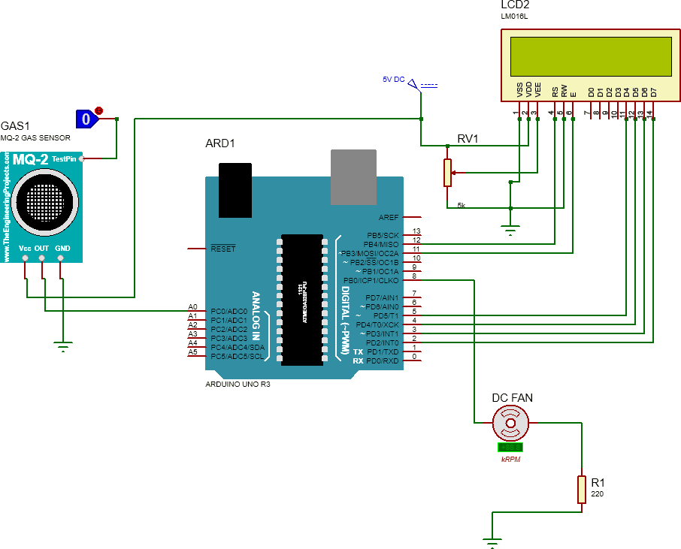
Figure 3.1 Circuit diagram

3.2 Working

We are using Arduino uno for controlling input- Sensor MQ135 and output devices-LCD, fan at the input side and as well as at the output side of our system. Starting with the sensor MQ135, the pin VDS is connected to the 5V DC supply. OUT pin is connected to the A0 of arduino. Next the output device LCD, the VSS pin is connected to the gnd. VDD is connected to the 5V dc supply. VEE and RW are connected to potentiometer.
In the circuit we are using Arduino with coding in it.

The RS pin is connected to the pin no.12 of arduino. E pin of the LCD is connected to pin no. 11 of arduino. The data pins of LCD – D4, D5, D6, D7 are connected to the pins – 5,4,3,2 of the arduino respectively. And finally, the DC fan is connected to the pin no. 9 of the arduino uno.

The index value obtained at A0 pin of arduino from the sensor is displayed on the LCD. If the air is highly polluted then the index value if high and is air is less polluted then the index value is low. The speed of the depends on this index value. Higher the value, higher the speed of rotation of the fan. Lower the value of index, lower the speed of the fan.

CHAPTER 4
COMPONENTS LIST AND SPECIFICATION
4.1 Components list and cost:

Table no. 4.1 Components list with cost
Sr.no | Component Name | Quantity | Cost(₹)
 | H12 hepa filter | 1 | 1299
 | Activated Carbon filter | 1 | 1290
 | Arduino UNO | 2 | 690
 | DC fan (120mm x 120mm) | 1 | 400
 | MQ135 (Air quality/gas sensor) | 2 | 500
 | LCD Display | 2 | 240
 | DC Choke (24V-36V) | 1 | 310
 | UV Lamp (11W) | 1 | 400
 | Solar Panel | 1 | 3000
 | Cotton filter (100x100cm) | 1 | 175
 | Potentiometer. | 2 | 140
 | Buck booster converters. | 1 | 80
TOTAL COST |  |  | 10,094

4.2 Component specification
4.2.1 H12 Hepa filter
HEPA ( high-efficiency particulate air) filter, also known as high-efficiency particulate absorbing filter and high-efficiency particulate arrestance filter, is an efficiency standard of air filter.
Filters meeting the HEPA standard must satisfy certain levels of efficiency. Common standards require that a HEPA air filter must remove—from the air that passes through—at least 99.95% (European Standard) or 99.97% (ASME, U.S. DOE) of particles whose diameter is equal to 0.3 μm; with the filtration efficiency increasing for particle diameters both less than and greater than 0.3 μm. HEPA filters capture pollen, dirt, dust, moisture, bacteria (0.2-2.0 μm), virus (0.02-0.3 μm), and submicron liquid aerosol (0.02-0.5 μm). Some microorganisms, for example, Aspergillus niger, Penicillium citrinum, Staphylococcus epidermidis, and Bacillus subtilis are captured by HEPA filters with photocatalytic oxidation (PCO). HEPA is also able to capture some viruses and bacteria which are ≤0.3 μm. HEPA is also able to capture floor dust which contains Bacteroidia, Clostridia, and Bacilli.
Features:
- Captures PM2.5, PM10, dust, bacteria, viruses, pollen, dust mites.
- Captures 99.95 percent 0.3-micron particles and other fine particles as small as 0.02 microns.
Specifications:
HEPA filters, as defined by the United States Department of Energy (DOE) standard adopted by most American industries, remove at least 99.97% of airborne particles 0.3 micrometers (μm) in diameter. The filter's minimal resistance to airflow, or pressure drop, is usually specified around 300 pascals (0.044 psi) at its nominal volumetric flow rate.
The specification used in the European Union: European Standard EN 1822-1:2009, from which ISO 29463 is derived, defines several classes of filters by their retention at the given most penetrating particle size (MPPS): Efficient Particulate Air filters (EPA), HEPA and Ultra Low Particulate Air filters (ULPA).
Figure 4.1 hepa filter
4.2.2 Activated Carbon filter
An activated carbon filter works by collecting pollutants that create smells and odors present in the environment. Carbon filtering works by adsorption, in which pollutants in the fluid to be treated are trapped inside the pore structure of a carbon substrate. The substrate is made of many carbon granules, each of which is itself highly porous. As a result, the substrate has a large surface area within which contaminants can be trapped. Activated carbon is typically used in filters, as it has been treated to have a much higher surface area than non-treated carbon. This filtered air is then passed to the UV filter for further filtration process.
Features:
- Air and Gas Purification — Activated carbon filters out odors, pollutants, and volatile organic compounds (VOCs) from the air by trapping gas molecules and removing them efficiently from circulation.
- Also, activated carbon can be used to detect and adsorb radon in the air.
Specifications:
Filtration velocity | 2-8 m3/h.m2
Contact time | 10 -30 minutes
Diameter | 50 cm to 3m
Filtration area | 0,2 to 7 m2
Flow rates | 10L/h 100 m3/h
Pressure ratings | 4 to10 bar
Vessel Materials | Epoxy-coated steel
 | Polyester composite
 | Stainless steel (on request)
Bed depth | 1 meter min.

Table no. 4.2 Specifications of carbon filter

Figure 4.2 Carbon Filter
4.2.3 Arduino UNO

The Arduino Uno is a microcontroller board based on the ATmega328. Arduino is an open-source, prototyping platform and its simplicity makes it ideal for hobbyists to use as well as professionals. The Arduino Uno has 14 digital input/output pins (of which 6 can be used as PWM outputs), 6 analog inputs, a 16 MHz crystal oscillator, a USB connection, a power jack, an ICSP header, and a reset button. It contains everything needed to support the microcontroller; simply connect it to a computer with a USB cable or power it with a AC-to-DC adapter or battery to get started

The Arduino Uno differs from all preceding boards in that it does not use the FTDI USB-to-serial driver chip. Instead, it features the Atmega8U2 microcontroller chip programmed as a USB-to-serial converter.
The Arduino Uno and version 1.0 will be the reference versions of Arduino, moving forward. The Uno is the latest in a series of USB Arduino boards, and the reference model for the Arduino platform.
Power: The Arduino Uno can be powered via the USB connection or with an external power supply. The power source is selected automatically. External (non-USB) power can come either from an AC-to-DC adapter (wall-wart) or battery. VIN. The input voltage to the Arduino board when it's using an external power source (as opposed to 5 volts from the USB connection or other regulated power source). You can supply voltage through this pin, or, if supplying voltage via the power jack, access it through this pin.
Memory: The ATmega328 has 32 KB (with 0.5 KB used for the boot loader). It also has 2 KB of SRAM and 1 KB of EEPROM (which can be read and written with the EEPROM library).
Input and Output: Each of the 14 digital pins on the Uno can be used as an input or output, using pinMode(), digitalWrite(), and digitalRead() functions. They operate at 5 volts. Each pin can provide or receive a maximum of 40 mA and has an internal pull-up resistor (disconnected by default) of 20-50 kOhms. In addition, some pins have specialized functions:
- TWI: A4 or SDA pin and A5 or SCL pin. Support TWI communication using the Wire library. There are a couple of other pins on the board:
- AREF: Reference voltage for the analog inputs. Used with analogReference().
- Reset: Bring this line LOW to reset the microcontroller. Typically used to add a reset button to shields which block the one on the board.
See also the mapping between Arduino pins and ATmega328 ports. The mapping for the Atmega8, 168, and 328 is identical.
USB Over current Protection: The Arduino Uno has a resettable polyfuse that protects your computer's USB ports from shorts and over current. Although most computers provide their own internal protection, the fuse provides an extra layer of protection. If more than 500 mA is applied to the USB port, the fuse will automatically break the connection until the short or overload is removed.
Communication: A Software Serial library allows for serial communication on any of the Uno's digital pins. The ATmega328 also supports I2C (TWI) and SPI communication. The Arduino software includes a Wire library to simplify use of the I2C bus; see the documentation for details. For SPI communication, use the SPI library.
Physical Characteristics: The maximum length and width of the Uno PCB are 2.7 and 2.1 inches respectively, with the USB connector and power jack extending beyond the former dimension. Four screw holes allow the board to be attached to a surface or case.
Features of the Arduino UNO:
- Microcontroller: ATmega328
- Operating Voltage: 5V
- Input Voltage (recommended): 7-12V
- Input Voltage (limits): 6-20V
- Digital I/O Pins: 14 (of which 6 provide PWM output)
- Analog Input Pins: 6
- DC Current per I/O Pin: 40 mA
- DC Current for 3.3V Pin: 50 mA
- Flash Memory: 32 KB of which 0.5 KB used by bootloader
- SRAM: 2 KB (ATmega328)
- EEPROM: 1 KB (ATmega328)
- Clock Speed: 16 MHz
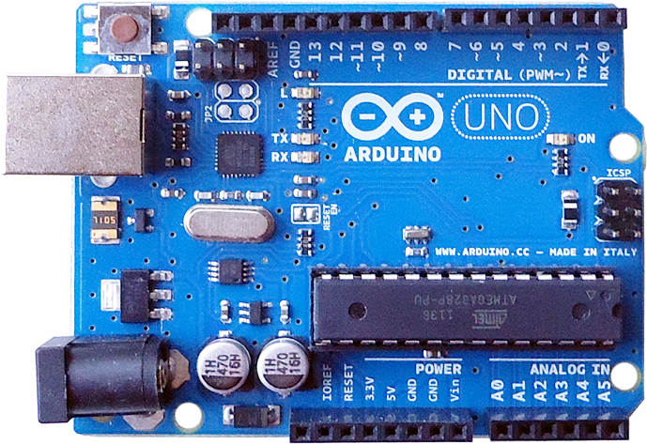
Figure 4.3 Arduino UNO
4.2.4 CPU fan (120mm x 120mm)
A fan on top of a computer processor. It helps pull and blow hot air off the processor, helping keep it cooler. It is designed to transfer the heat generated.

Features:
- Used to cool the CPU (central processing unit) heat sink.
- Effective cooling of a concentrated heat source such as a large-scale integrated circuit requires a heat sink, which may be cooled by a fan; use of a fan alone will not prevent overheating of the small chip.

Specifications:
Packaging Type | carton
Country of Origin | Made in India
Rated Voltage | 12VDC
Fan speed | 2500RPM
Air Flow | 36.45CFM

Table no. 4.3 Specifications of CPU fan

- Very low noise.
- Material: hard plastic.
- Colour: black.

Figure 4.4 Dc fan

4.2.5 MQ135 (Air quality/gas sensor)
Air quality sensor for detecting a wide range of gases, including NH3, NOx, alcohol, benzene, smoke and CO2. Ideal for use in office or factory. MQ135 gas sensor has high sensitivity to Ammonia, Sulfide and Benze steam, also sensitive to smoke and other harmful gases. Through this sensor we can detect the air quality in the environment. If the air quality is good in the surrounding then the system is turned OFF and again turned ON if there is bad air quality in the surrounding.
Features:
- High Sensitivity.
- High sensitivity to Ammonia, Sulfide and Benze.
- Stable and Long Life.
- Detection Range: 10 - 300 ppmb NH3, 10 - 1000 ppm Benzene, 10 - 300 Alcohol.
- Heater Voltage: 5.0V.
- Dimensions: 18mm Diameter, 17mm High excluding pins, Pins - 6mm High.
- Long life and low cost.

Specifications:
- Wide detecting scope.
- Fast response and High sensitivity.
- Stable and long life.
- Operating Voltage is +5V.
- Detect/Measure NH3, NOx, alcohol, Benzene, smoke, CO2, etc.
- Analog output voltage: 0V to 5V.
- Digital output voltage: 0V or 5V (TTL Logic)
- Preheat duration 20 seconds.

Figure 4.5 Air Quality Sensor

4.2.6 LCD Display
A liquid crystal display (LCD) has liquid crystal material sandwiched between two sheets of glass. Without any voltage applied between transparent electrodes, liquid crystal molecules are aligned in parallel with the glass surface.

Features:
- Native Resolution. Unlike CRT monitors, LCD monitors display information well at only the resolution they are designed for, which is known as the native resolution.
- Viewing Angle
- Brightness or Luminance
- Contrast Ratio
- Response Rate
- Adjustability

Specifications:
- Operating Voltage is 4.7V to 5.3V.
- Current consumption is 1mA without backlight.
- Alphanumeric LCD display module, meaning can display alphabets and numbers.
- Consists of two rows and each row can print 16 characters.
- Each character is build by a 5×8 pixel box.
- Can work on both 8-bit and 4-bit mode.

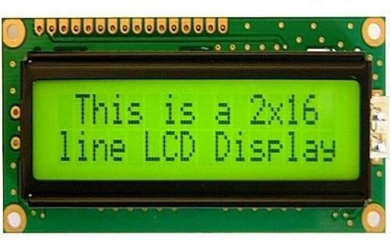
Figure 4.6 LCD Display

4.2.7 Aqualex DC Choke (24V-36V)
In electronics, a choke is an inductor used to block higher-frequency while passing direct current (DC) and lower-frequencies of alternating current (AC). The DC choke is used to give supply to the UV lamp used in our system.
Features:
MTE's DC LINK CHOKES, also referred to as DC line chokes or inductor chokes, are an economical means of filtering and controlling the DC bus voltage and current in a variable speed drive/inverter. They help reduce AC input line current harmonic distortion while absorbing DC bus voltage spikes.

Specifications:
- UL-508 Component recognized
- 1000 Volts DC maximum
- For ripple frequency of 300hz or 360hz
- Suitable for 40 C ambient temperature
- Class B Insulation System (130C)
- Suitable for ripple current of 10% peak-to-peak
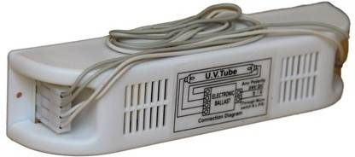
Figure 4.7 DC Choke

4.2.8 UV Lamp (11W)
UV air purifiers are designed to use short-wave ultraviolet light (UV-C light) to inactivate airborne pathogens and microorganisms like mold, bacteria and viruses. As air is forced through the device, it passes UV lamps, which directly attempt to disinfect the air by means of germicidal irradiation. UV light air purifiers are generally a combination of a forced air system and another filter (like a HEPA filter). As a result, the UV light of the air purifier acts together with other processes to clean the air.
Features:
UV (Ultraviolet) Air Purifiers utilize ultraviolet light to kill mold and mildew, as well as eradicate VOC's, airborne pathogens, flu, germs, bacteria, viruses, and other harmful airborne contaminants. Some models also remove odors from the home caused by garbage, hobbies, cooking, etc.
Specifications:
Though UV-C light can potentially deactivate microbes, whether it can do so within a portable air purifier unit is a different matter altogether. These units are often advertised to reduce dust mite and mold allergens.
The effectiveness of UV-C light in disinfecting the air depends on a number of factors, including:
- Whether the pollutants come into contact with the UV light
- Whether the light is inhibited by the cooling effect of airflow
- The material of the bulb emitting such light
- The high dosage of light required
- How long the pollutant is exposed to the light

Figure 4.8 UV Lamp

4.2.9 Solar Panel
Sunlight hits the solar panels, and creates an electric field. The electricity generated flows to the edge of the panel, and into a conductive wire. The conductive wire brings the electricity to the DC charge controller.
Features:
- High Efficiency
- Long service life
- Robust construction
- Lower electric bills
- Negligible maintenance
- Easy installment
- Advanced Cell Encapsulation & moving.
Specifications:
- Monocrystalline Silicon solar cells
- Encapsulated: PC film lamination
- Open Circuit Voltage(Voc) 4.6V±8%
- Short Circuit Current (Isc) 105mA±8%
- Maximum Power Voltage(Vmp) 4.0V±8%
- Maximum Power Current(Imp) 100.0mA±8%
- Maximum Power(Ppm) 0.4W±8%

Figure 4.9 Solar Panel

4.2.10 Cotton filter (100x100cm)
Cotton Filter Paper: Cotton Filter Paper is widely used to filter the liquids from the solid particles present in the liquids. It is used to separate the dirt from the liquids to make it purified. Can also be oil and water to purify.
Features:
- The cotton ball layer helps to keep the other layers of your filter from falling out into your water.
- The sand layer acts as a coarse filter for large muddy particles and to keep the activated charcoal or clay particles from getting into the cleaned water.

Specifications:

Usage/Application | Water Filter
Filter Medium Material | Cotton
Color | White
Outer Diameter | 63 mm (Standard size), 115 mm (Jumbo size)
Inner Diameter | 28 mm
Table no. 4.4 Specifications of cotton filter

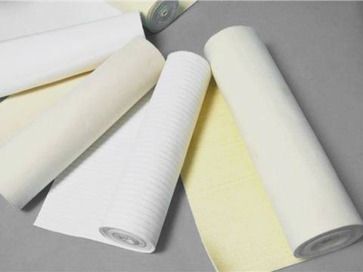

Figure 4.10 Cotton filter

4.2.11 Potentiometer

A potentiometer is a three-terminal resistor with a sliding or rotating contact that forms an adjustable voltage divider. If only two terminals are used, one end and the wiper, it acts as a variable resistor or rheostat.

Features:
The taper, resolution, hop on hop off resistance and the marking codes are the main characteristics of a potentiometer. There are many applications of a potentiometer, from audio controller circuit to measuring distances, angle or voltages. It is very versatile in nature.
The measuring instrument called a potentiometer is essentially a voltage divider used for measuring electric potential (voltage); the component is an implementation of the same principle, hence its name. Potentiometers are commonly used to control electrical devices such as volume controls on audio equipment.

Specifications:
- Type: Rotary a.k.a Radio POT.
- Available in different resistance values like 500Ω, 1K, 2K, 5K, 10K, 22K, 47K, 50K, 100K, 220K, 470K, 500K, 1 M.
- Power Rating: 0.3W.
- Maximum Input Voltage: 200Vdc.
- Rotational Life: 2000K cycles.

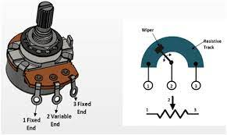
Figure 4.11 Potentiometer

4.2.12 Buck boost converters
The buck–boost converter is a type of DC-to-DC converter that has an output voltage magnitude that is either greater than or less than the input voltage magnitude. It is equivalent to a flyback converter using a single inductor instead of a transformer.^{[1]}
Two different topologies are called buck–boost converter. Both of them can produce a range of output voltages, ranging from much larger (in absolute magnitude) than the input voltage, down to almost zero.

Features:
The buck and boost converters, the operation of the buck-boost is best understood in terms of the inductor's "reluctance" to allow rapid change in current. From the initial state in which nothing is charged and the switch is open, the current through the inductor is zero. When the switch is first closed, the blocking diode prevents current from flowing into the right hand side of the circuit, so it must all flow through the inductor.
However, since the inductor doesn't allow rapid current change, it will initially keep the current low by dropping most of the voltage provided by the source. Over time, the inductor will allow the current to slowly increase by decreasing its own resistance.
In an ideal circuit the voltage drop across the inductor would remain constant. When the inherent resistance of wires and the switch is taken into account then the voltage drop across the inductor will also decrease as the current increases. Also during this time, the inductor will store energy in the form of a magnetic field.

Specifications:
- Input Current：3A ( max )
- No-load 18mA (5V input , 8V output , no-load is less than 18mA. Higher the voltage , the greater the load current . )
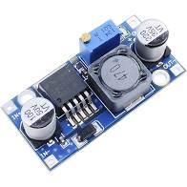

Figure 4.12 Buck Boost Converter

CHAPTER 5
ALGORITHM, FLOWCHART AND PROGRAMMING

5.1 ALGORITHM:
1. Solar panel converts solar energy into electrical energy.
2. Buck boost converter receives the from solar and provides required voltage to the arduino.
3. Air quality sensor MQ135 senses the quality of surrounding air and depending upon its output analog value, speed of the fan is determined.
4. If the value given by sensor is below threshold value then the system goes into standby mode
5. Air purifier consists of various filters. Surrounding air is passed through them to filter the dust particles and pollutants present in the air.
6. Purified and clean air is let out in the surrounding.

5.2 Flowchart :
Start

Solar panel converts solar energy into electrical energy.

Buck boost converter receives the from solar and provides required voltage to the arduino.

Air quality sensor MQ135 senses the quality of surrounding air and depending upon its output analog value, speed of the fan is determined

If the value given by sensor is below threshold value then the system goes into standby mode.

Air purifier consists of various filters. Surrounding air is passed through them to filter the dust particles and pollutants present in the air.

Stop

5.3 PROGRAMMING:
Arduino program:
#include <LiquidCrystal.h> //LCD Library
#define fan 8 //beeper on Digital 8
#define sensor A0 //sensor on Analog 0
LiquidCrystal lcd(12, 11, 5, 4, 3, 2); //Create instance of LCD
int gasLevel = 0; //int variable for gas level
String quality ="";
int Qval;

void setup() {
Serial.begin(9600); //start serial comms
pinMode(fan,OUTPUT); //set beeper for output
pinMode(sensor,INPUT); //set sensor for input
analogWrite(fan,0);
lcd.begin(16, 2); //initial LCD setup
lcd.setCursor (0,0); //splash screen and warmup
lcd.print(" ");
lcd.setCursor (0,1);
lcd.print(" ");
lcd.setCursor (0,0);
lcd.print(" Air Sensor ");
lcd.setCursor (0,1);
lcd.print(" Warming Up ");
delay(2000); //set for at least 2 minutes
lcd.setCursor (0,0); //clear screen
lcd.print(" ");
lcd.setCursor (0,1);
lcd.print(" ");
}

void loop() {
gasLevel = analogRead(sensor);
// gasLevel = 300;

if(gasLevel<175){
quality = " GOOD! ";
}
else if (gasLevel >175 && gasLevel<225){
quality = "Moderate ";
}
else if (gasLevel >225 && gasLevel<300){
quality = "Unhealthy";
}
else if (gasLevel >300){
quality = "Very Unhealthy ";
}
lcd.setCursor (0,0);
lcd.print("Quality index:");
lcd.setCursor(0,1);
lcd.print(gasLevel);
delay(5000);
lcd.setCursor (0,0); //clear screen
lcd.print(" ");
lcd.setCursor (0,1);
lcd.print(" ");
lcd.setCursor (0,0);
lcd.print("Quality is: ");
lcd.setCursor(0,1);
lcd.print(quality);
//digitalWrite(8,HIGH);
}

5.4 PROGRAMMING TOOLS

Arduino
The Arduino Integrated Development Environment - or Arduino Software (IDE) - contains a text editor for writing code, a message area, a text console, a toolbar with buttons for common functions and a series of menus. It connects to the Arduino and Genuino hardware to upload programs and communicate with them.

Writing Sketches
Programs written using Arduino Software (IDE) are called sketches. These sketches are written in the text editor and are saved with the file extension .ino. The editor has features for cutting/pasting and for searching/replacing text. The message area gives feedback while saving and exporting and also displays errors. The console displays text output by the Arduino Software (IDE), including complete error messages and other information. The bottom righthand corner of the window displays the configured board and serial port. The toolbar buttons allow you to verify and upload programs, create, open, and save sketches, and open the serial monitor.
NB: Versions of the Arduino Software (IDE) prior to 1.0 saved sketches with the extension .pde. It is possible to open these files with version 1.0, you will be prompted to save the sketch with the .ino extension on save.
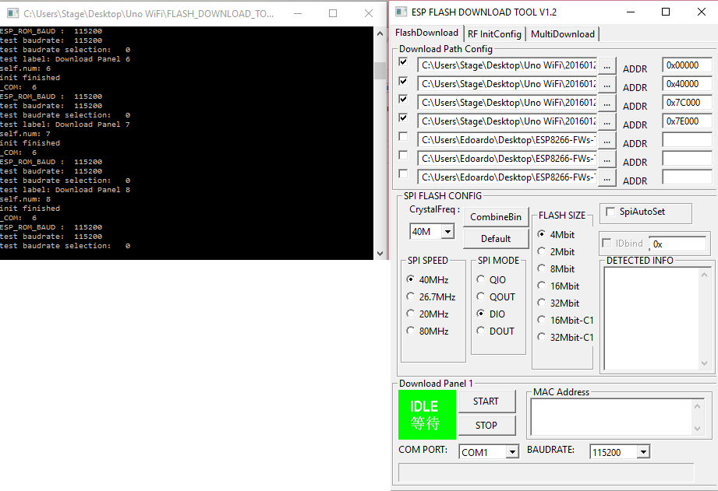
Figure 5.1 writing sketches
Additional commands are found within the five menus: File, Edit, Sketch, Tools, Help. The menus are context sensitive, which means only those items relevant to the work currently being carried out are available.

File
- New
Creates a new instance of the editor, with the bare minimum structure of a sketch already in place.
- Open
Allows to load a sketch file browsing through the computer drives and folders.
- OpenRecent
Provides a short list of the most recent sketches, ready to be opened.
- Sketchbook
Shows the current sketches within the sketchbook folder structure; clicking on any name opens the corresponding sketch in a new editor instance.
- Examples
Any example provided by the Arduino Software (IDE) or library shows up in this menu item. All the examples are structured in a tree that allows easy access by topic or library.
- Close
Closes the instance of the Arduino Software from which it is clicked.
- Save
Saves the sketch with the current name. If the file hasn't been named before, a name will be provided in a "Save as.." window.
- Save as...
Allows to save the current sketch with a different name.
- Page Setup
It shows the Page Setup window for printing.
- Print
Sends the current sketch to the printer according to the settings defined in Page Setup.
- Preferences
Opens the Preferences window where some settings of the IDE may be customized, as the language of the IDE interface.
- Quit
Closes all IDE windows. The same sketches open when Quit was chosen will be automatically reopened the next time you start the IDE.

Edit
- Undo/Redo
Goes back of one or more steps you did while editing; when you go back, you may go forward with Redo.
- Cut
Removes the selected text from the editor and places it into the clipboard.
- Copy
Duplicates the selected text in the editor and places it into the clipboard.
- Copy for Forum
Copies the code of your sketch to the clipboard in a form suitable for posting to the forum, complete with syntax coloring.
- Copy as HTML
Copies the code of your sketch to the clipboard as HTML, suitable for embedding in web pages.
- Paste
Puts the contents of the clipboard at the cursor position, in the editor.
- Select All
Selects and highlights the whole content of the editor.
- Comment/Uncomment
Puts or removes the // comment marker at the beginning of each selected line.
- Increase/Decrease Indent
Adds or subtracts a space at the beginning of each selected line, moving the text one space on the right or eliminating a space at the beginning.
- Find
Opens the Find and Replace window where you can specify text to search inside the current sketch according to several options.
- Find Next
Highlights the next occurrence - if any - of the string specified as the search item in the Find window, relative to the cursor position.
- Find Previous
Highlights the previous occurrence - if any - of the string specified as the search item in the Find window relative to the cursor position.

Sketch
- Verify/Compile
Checks your sketch for errors compiling it; it will report memory usage for code and variables in the console area.
- Upload
Compiles and loads the binary file onto the configured board through the configured Port.
- UploadUsingProgrammer
This will overwrite the bootloader on the board; you will need to use Tools > Burn Bootloader to restore it and be able to Upload to USB serial port again. However, it allows you to use the full capacity of the Flash memory for your sketch. Please note that this command will NOT burn the fuses. To do so a Tools -> Burn Bootloader command must be executed.
- Export Compiled Binary
Saves a .hex file that may be kept as archive or sent to the board using other tools.
- Show Sketch Folder
Opens the current sketch folder.
- IncludeLibrary
Adds a library to your sketch by inserting #include statements at the start of your code. For more details, see libraries below. Additionally, from this menu item you can access the Library Manager and import new libraries from .zip files.
- AddFile...
Adds a source file to the sketch (it will be copied from its current location). The new file appears in a new tab in the sketch window. Files can be removed from the sketch using the tab menu accessible clicking on the small triangle icon below the serial monitor one on the right side o the toolbar.

Tools
- AutoFormat
This formats your code nicely: i.e. indents it so that opening and closing curly braces line up, and that the statements inside curly braces are indented more.
- ArchiveSketch
Archives a copy of the current sketch in .zip format. The archive is placed in the same directory as the sketch.
- FixEncoding&Reload
Fixes possible discrepancies between the editor char map encoding and other operating systems char maps.
- SerialMonitor
Opens the serial monitor window and initiates the exchange of data with any connected board on the currently selected Port. This usually resets the board, if the board supports Reset over serial port opening.
- Board
Select the board that you're using. See below for descriptions of the various boards.
- Port
This menu contains all the serial devices (real or virtual) on your machine. It should automatically refresh every time you open the top-level tools menu.
- Programmer
For selecting a harware programmer when programming a board or chip and not using the onboard USB-serial connection. Normally you won't need this, but if you're burning a bootloader to a new microcontroller, you will use this.
- BurnBootloader
The items in this menu allow you to burn a bootloader onto the microcontroller on an Arduino board. This is not required for normal use of an Arduino or Genuino board but is useful if you purchase a new ATmega microcontroller (which normally comes without a bootloader). Ensure that you've selected the correct board from the Boards menu before burning the bootloader on the target board. This command also set the right fuses.

Help
Here you find easy access to a number of documents that come with the Arduino Software (IDE). You have access to Getting Started, Reference, this guide to the IDE and other documents locally, without an internet connection. The documents are a local copy of the online ones and may link back to our online website.
- FindinReference
This is the only interactive function of the Help menu: it directly selects the relevant page in the local copy of the Reference for the function or command under the cursor.

Sketchbook
The Arduino Software (IDE) uses the concept of a sketchbook: a standard place to store your programs (or sketches). The sketches in your sketchbook can be opened from the File > Sketchbook menu or from the Open button on the toolbar. The first time you run the Arduino software, it will automatically create a directory for your sketchbook. You can view or change the location of the sketchbook location from with the Preferences dialog.
Beginning with version 1.0, files are saved with a .ino file extension. Previous versions use the .pde extension. You may still open .pde named files in version 1.0 and later, the software will automatically rename the extension to .ino.

Tabs, Multiple Files, and Compilation
Allows you to manage sketches with more than one file (each of which appears in its own tab). These can be normal Arduino code files (no visible extension), C files (.c extension), C++ files (.cpp), or header files (.h).

Uploading
When you upload a sketch, you're using the Arduino bootloader, a small program that has been loaded on to the microcontroller on your board. It allows you to upload code without using any additional hardware. The bootloader is active for a few seconds when the board resets; then it starts whichever sketch was most recently uploaded to the microcontroller. The bootloader will blink the on-board (pin 13) LED when it starts (i.e. when the board resets).

Libraries
Libraries provide extra functionality for use in sketches, e.g. working with hardware or manipulating data. To use a library in a sketch, select it from the Sketch > Import Library menu. This will insert one or more #include statements at the top of the sketch and compile the library with your sketch. Because libraries are uploaded to the board with your sketch, they increase the amount of space it takes up. If a sketch no longer needs a library, simply delete its #includestatements from the top of your code.
There is a list of libraries in the reference. Some libraries are included with the Arduino software. Others can be downloaded from a variety of sources or through the Library Manager. Starting with version 1.0.5 of the IDE, you do can import a library from a zip file and use it in an open sketch. See these instructions for installing a third-party library.
.Third-Party Hardware
Support for third-party hardware can be added to the hardware directory of your sketchbook directory. Platforms installed there may include board definitions (which appear in the board menu), core libraries, bootloaders, and programmer definitions. To install, create the hardware directory, then unzip the third-party platform into its own sub-directory. (Don't use "Arduino" as the sub-directory name or you'll override the built-in Arduino platform.) To uninstall, simply delete its directory.
For details on creating packages for third-party hardware, see the Arduino IDE 1.5 3rd party Hardware specification.

Serial Monitor
Displays serial data being sent from the Arduino or Genuino board (USB or serial board). To send data to the board, enter text and click on the "send" button or press enter. Choose the baud rate from the drop-down that matches the rate passed to Serial.begin in your sketch. Note that on Windows, Mac or Linux, the Arduino or Genuino board will reset (rerun your sketch execution to the beginning) when you connect with the serial monitor.
You can also talk to the board from Processing, Flash, MaxMSP, etc (see the interfacing page for details).

Preferences
Some preferences can be set in the preferences dialog (found under the Arduino menu on the Mac, or File on Windows and Linux). The rest can be found in the preferences file, whose location is shown in the preference dialog.

Language Support
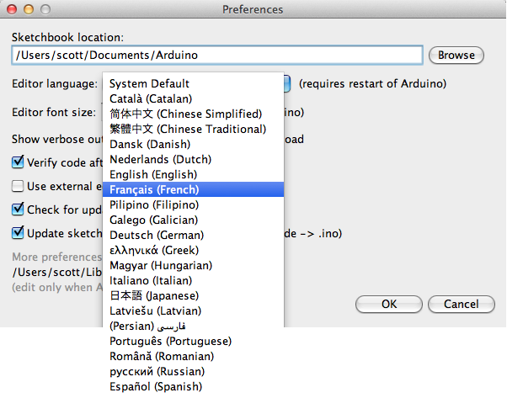
Figure 5.2 language support
Since version 1.0.1 , the Arduino Software (IDE) has been translated into 30+ different languages. By default, the IDE loads in the language selected by your operating system. (Note: on Windows and possibly Linux, this is determined by the locale setting which controls currency and date formats, not by the language the operating system is displayed in.)
If you would like to change the language manually, start the Arduino Software (IDE) and open the Preferences window. Next to the Editor Language there is a dropdown menu of currently supported languages. Select your preferred language from the menu, and restart the software to use the selected language. If your operating system language is not supported, the Arduino Software (IDE) will default to English.
You can return the software to its default setting of selecting its language based on your operating system by selecting System Default from the Editor Language drop-down. This setting will take effect when you restart the Arduino Software (IDE). Similarly, after changing your operating system's settings, you must restart the Arduino Software (IDE) to update it to the new default language.

Boards
The board selection has two effects: it sets the parameters (e.g. CPU speed and baud rate) used when compiling and uploading sketches; and sets and the file and fuse settings used by the burn bootloader command. Some of the board definitions differ only in the latter, so even if you've been uploading successfully with a particular selection you'll want to check it before burning the bootloader. You can find a comparison table between the various boards here.
Arduino Software (IDE) includes the built in support for the boards in the following list, all based on the AVR Core. The Boards Manager included in the standard installation allows to add support for the growing number of new boards based on different cores like Arduino Due, Arduino Zero, Edison, Galileo and so on.

CHAPTER 6
TESTING AND TROUBLESHOOTING
6.1 Basic troubleshooting techniques
Mistakes and component failure are a fact of life. Circuit boards will be made with mistakes in them, components will be soldered in backwards or in the wrong position, and components go bad all of which will make a circuit work poorly or not at all. PCB troubleshooting can be a monumental task that taxes both the will and the mind. Luckily there are a few tricks and techniques that can greatly speed up the search for the troublesome 'feature.

First we implemented the circuit diagram on the breadboard and verified whether the connections where right or not. First we connected the LCD pins and then the Arduino to the circuit. After the errors and trails, the circuit worked successfully.

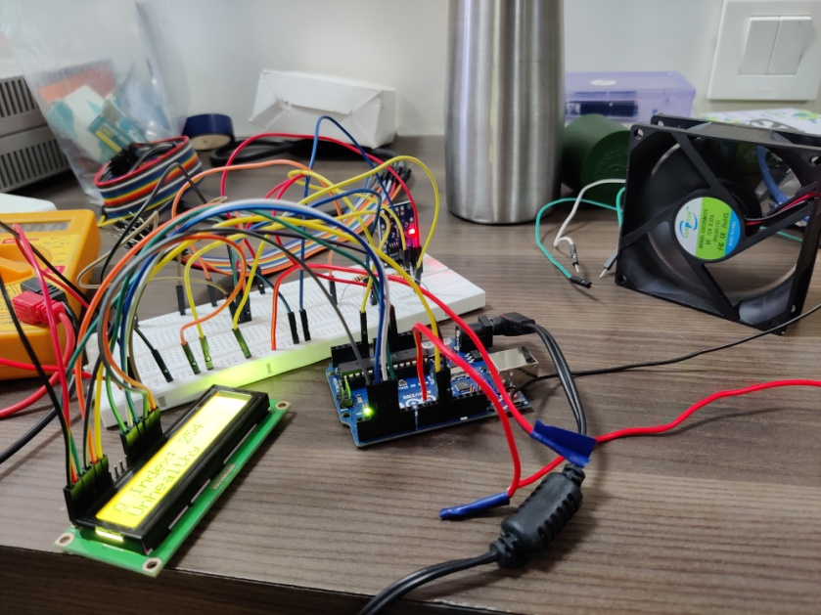
Figure 6.1 Implementation of circuit on breadboard

6.1.1 Troubleshooting of sensor MQ135:

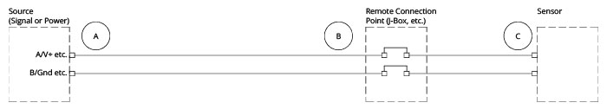
6.2 Troubleshooting of sensor MQ135
Multimeter test: continuity
We started with the multimeter continuity test. We want to make sure that all the wires are connected correctly.
1. Disconnect the wires for the sensor at its power source (Point A in the diagram).
2. Plug the black probe into the COM (common) port on your multimeter. Plug the red probe into the VΩ port.
3. Set your multimeter to Continuity - the symbol looks a bit like this: •))).
4. Connect the red probe to the + wire going to the sensor, and connect the black probe to the ground wire going to the sensor.
5. If the multimeter registers a reading, your circuit wiring is intact. If the multimeter does not register a reading, then there is something wrong with the wiring. Repeat these steps along the various sections of the circuit between the source and sensor to isolate the problem.
6. This process can (and should!) also be performed with your sensor’s communication wiring.
Multimeter test: voltage
Having established the continuity of the circuit, we checked the source voltage, but not at the source.
1. Reconnect the sensor’s power source.
2. Disconnect the power wires at the sensor (Point C in the diagram) or connection point closest to the sensor (Point B, if the cable to your sensor cannot be disconnected at the sensor).
3. Maintain the same probe – multimeter connections.
4. Connect the red probe to the incoming + wire, pin, or terminal, and the black probe to the ground wire/pin/terminal.
5. Select the DCV value on the multimeter that is closest to, yet bigger than, the source voltage.
6. Turn on the power source.
7. Verify that the voltage at the sensor is within the range suggested in your user manual. If so, we’ve eliminated source voltage as the problem. If not, the voltage source is at least a problem, if not the problem. (And either way, turn the power source back off!).
Multimeter test: resistance
Next, we checked circuit impedance or resistance*. In general, circuit impedance is only critical for communication circuits (Modbus, Hart, etc.), but checking can still be instructive for other circuits.
1. Reconnect the power wires at the sensor.
2. Disconnect the communication wires for the sensor at the source (Point A).
3. Maintain the same probe – multimeter connections.
4. As before, connect the red probe to the + wire going to the sensor, and connect the black probe to the ground wire going to the sensor.
5. Many sensors that use communication protocols require a minimum of 150Ω to 180Ω, so choose the Ohm value on the multimeter that is closest to, yet bigger than, 200Ω. If the circuit impedance is less than that recommended by your user manual, then add an appropriate amount of resistance to the circuit.
6. If the multimeter doesn’t register the impedance, select the next highest denomination of Ohms. If the circuit’s impedance is too high (and not infinite), something will need to be removed from the circuit (switch to a smaller wire size, too many intermediate junctions, etc).

6.1.2 PCB Troubleshooting
Printed circuit boards, or PCBs, are a mass of insulators and copper traces that connect densely packed components together to create a modern circuit. Troubleshooting a multi-layer PCB is often quite a challenge, with factors such as size, number of layers, signal analysis, and types of components playing a large role in the ease of troubleshooting. Some more complicated boards will require specialized equipment to properly troubleshoot, but most troubleshooting can be done with basic electronic equipment to follow traces, currents, and signals through the circuit.
Tools
Most basic PCB troubleshooting can be done with just a few tools. The most versatile tool is a multimeter, but depending on the complexity of the PCBs and the problem, an LCR meter, oscilloscope, power supply and logic analyzer may also be needed to dig deep into the operational behavior of the circuit.

Techniques (Visual)
A visual inspection of PCBs can find several potential issues. Overlapped traces, burnt out components, signs of overheating, and missing components can be found easily through a thorough visual inspection. Some burnt components, damaged through excessive current, cannot be seen easily, but a magnified visual inspection or the smell can indicate the presence of a damaged component.

Physical Inspection
One step beyond a visual inspection is a powered physical inspect with power applied to the circuit. By touching the surface of the PCB and the components on the board, hot spots can be detected without the use of an expensive thermo graphic camera. When a hot component is detected, it can be cooled with compressed canned air to test the circuit operation with the component at lower temperatures. This technique is potentially dangerous and should only be used on low voltage circuits with the proper safety precautions.
When physically touching a powered circuit, several precautions should be taken. Make sure that only one hand makes contact with the circuit at any time. This prevents an electrical shock from traveling across the heart, a potentially fatal shock. Keeping one hand in your pocket is a good technique when working on live circuits to prevent such shocks. Ensuring all potential current paths to ground, such as your feet or a non-resistive grounding strap, are disconnected is also essential to reduce the danger of shocks.
Touching various parts of the circuit will also change the impedance of the circuit which can change the behavior of the system and can be used to identify locations in the circuit that need additional capacitance to work correctly.

6.1.3 ICs Testing
The most challenging components to check are ICs. Most ICs can be easily identified by their markings and many can be operationally tested using oscilloscopes and logic analyzers, but the number of specialty ICs in various configurations and PCB designs can make testing ICs very challenging. Often a useful technique is to compare the behavior of a circuit to a known good circuit, which should help anomalous behavior to stand out.

6.2 Troubleshooting
1. After performing the circuit on breadboard successfully, we implemented the circuit on the PCB board and soldered the components.
2. In Arduino software we compiled the program and loaded it onto Arduino board.
3. The sensor of the input monitoring system gives the input to the Arduino and depending upon the input quality index , the speed of the fan varies.
4. The input quality index is displayed on the LCD display. Further the air is purified with the help of filters and the quality index of the purified air is displayed on the output monitoring system.
5. The quality index of the output monitoring system is less then the quality index of the input monitoring system. Hence the air is purified successfully.
6. Hence we conclude that the Air Purifier works properly.

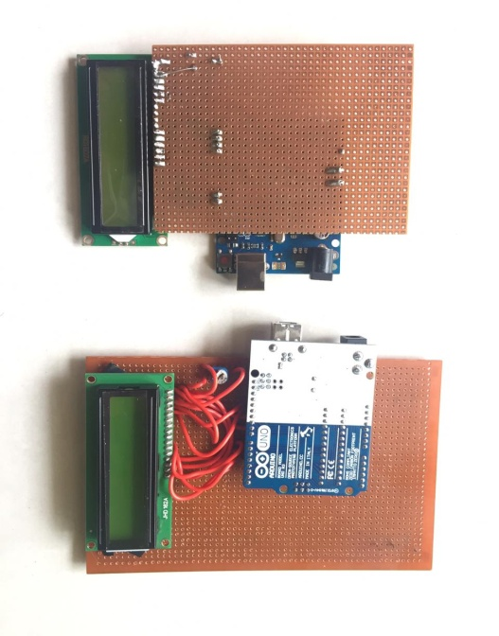
Figure 6.3 PCB Implementation

6.3 Fault finding and debugging:
Problems:
1. The LCD display was not turning ON.
2. The LCD displayed blank lines.
3. The Fan didn’t start on its own means. When pushed with a finger it started rotating, but slower than normal, and was very easy to stop.
Troubleshooting :
1. By checking the connectivity of the LCD display, the first problem was solved.
2. This problem occurred because we had set the contrast control resistor value too high. It was then solved by selecting the value to be around 4.7K ohms.
3. The 12V power supply was not fed properly to the fan therefore this problem arrived. By checking the connectivity of the circuit this problem was solved.

CHAPTER 7
RESULT

1. After checking the connectivity of the circuit we implemented the circuit on the PCB board. The required output was displayed on the LCD at the output side of the project.
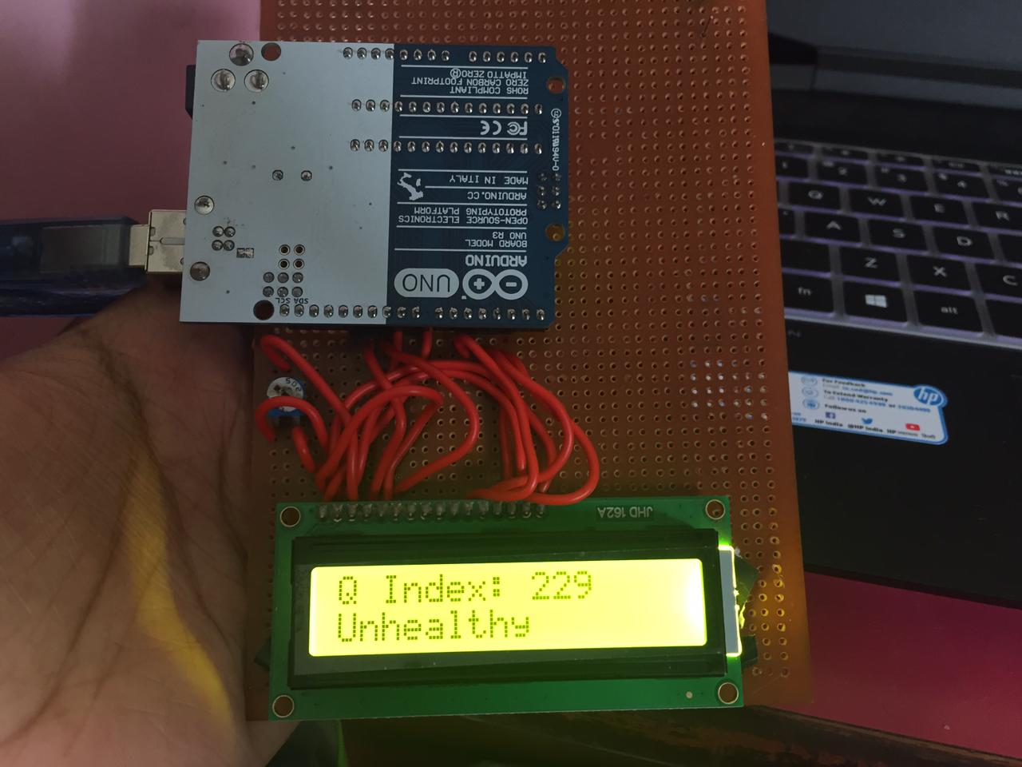
Figure 7.1 Quality Index at the output side

2. Further we attached the fan at the centre and the arduino circuits at the input as well as at the output side, inside a cardboard box.
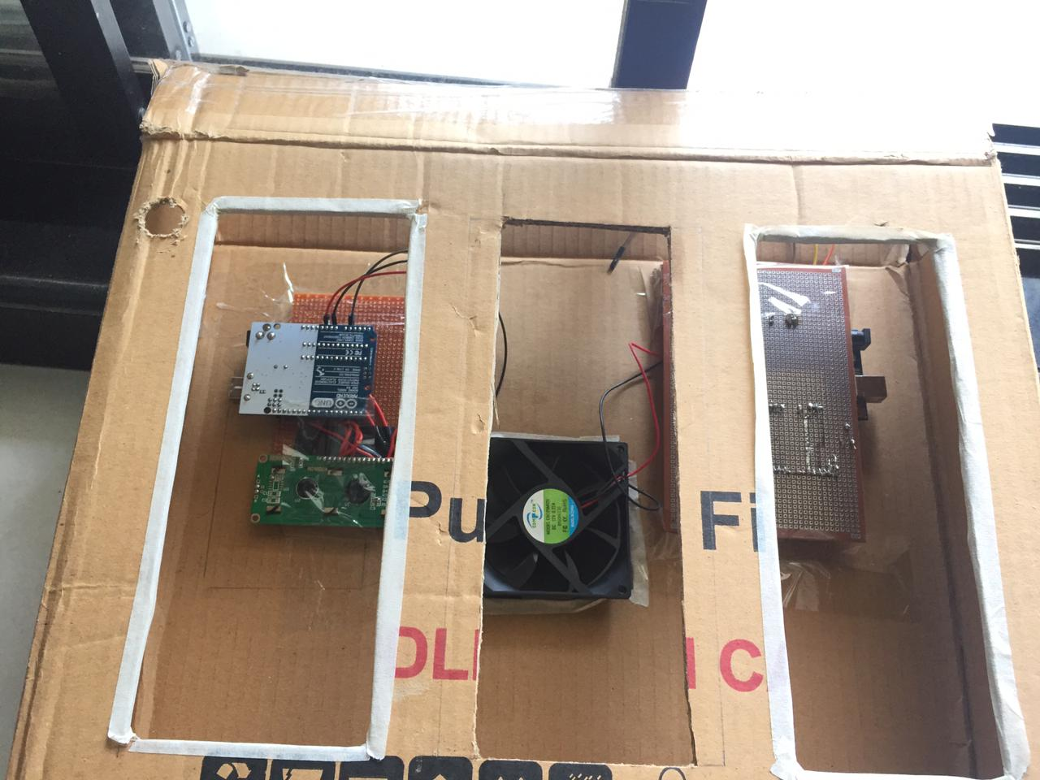
Figure 7.2 Implementation of Air purifier(1)

3. Next we inserted the HEPA filter and the Carbon activated filter inside the box and adjusted it according to our system design.

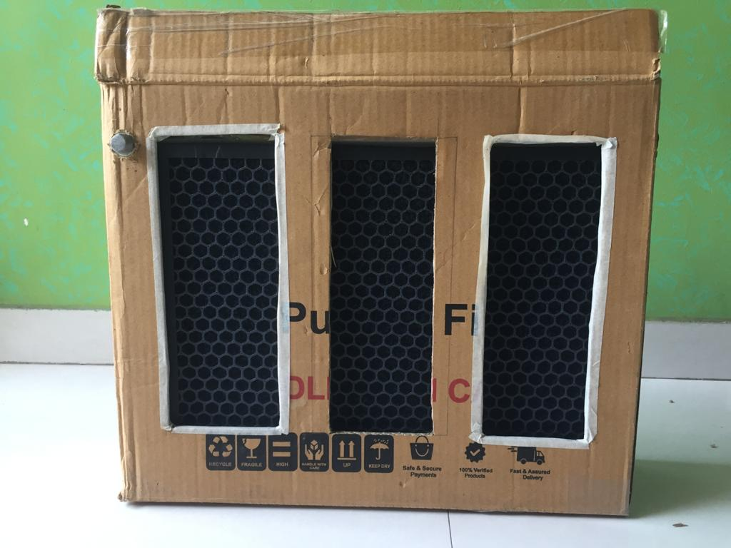
Figure 7.3 Implementation of Air purifier(2)

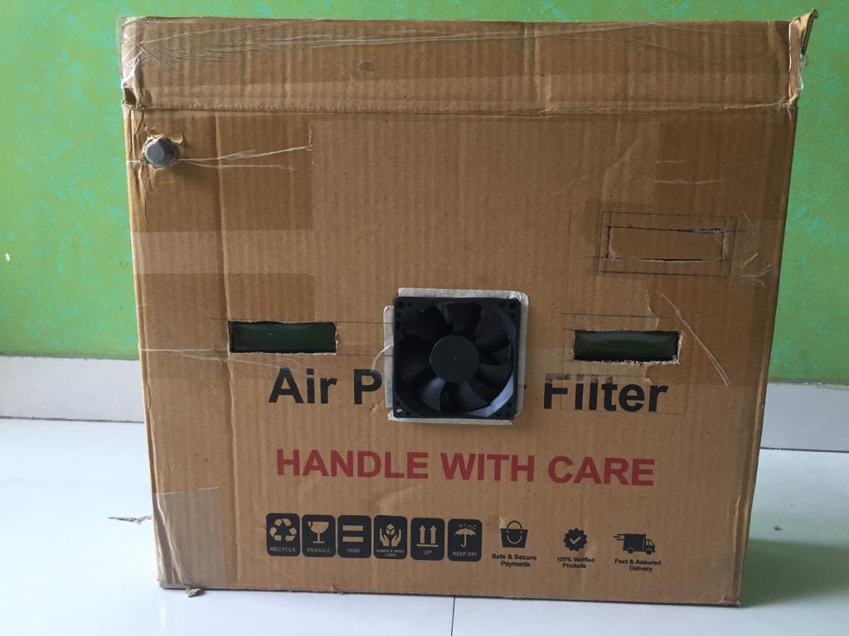
Figure 7.4 Front view of Air purifier
.

4. The difference in the input air quality and the output air quality can be seen in the figure (7.5). Therefore our system works properly and lets the purified air in the surrounding.

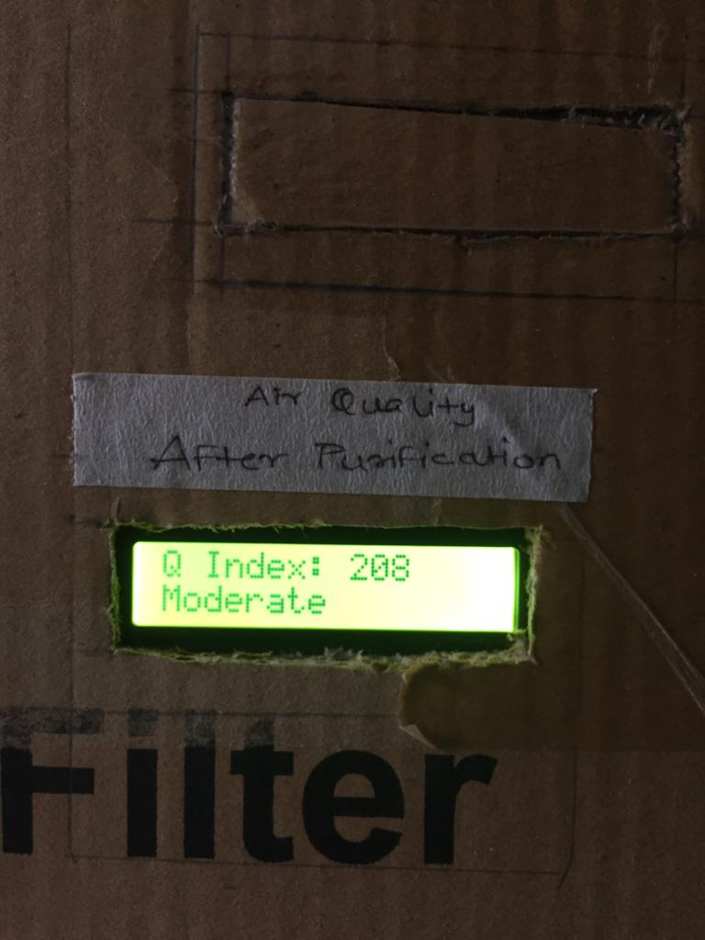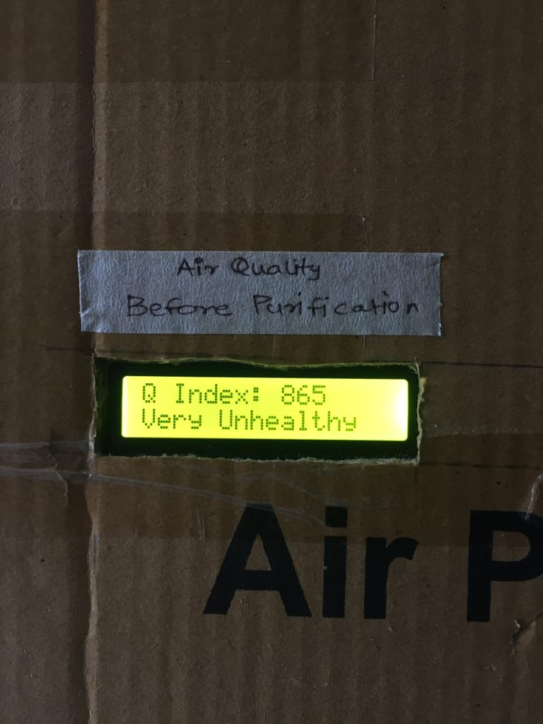
Figure 7.5 Air quality purification

CHAPTER 8
ADVANTAGES, LIMITATIONS, APPLICATIONS, FUTURE SCOPE AND CONCLUSION
8.1 Advantages:
- Air purifiers with HEPA technology filters can remove 99.7 percent of the airborne particulate matter (PM) circulating in your home environment. Removing these pollutants can lead to several immediate and long term health benefits such as better sleep quality and increased life expectancy
- Relieves Symptoms of Asthma
- Eliminates Harmful Chemicals from Indoor Environments.
- Neutralizes Unpleasant Odors.
- Reduces the Chances of Airborne Diseases.
- Improves Sleep.
- Removes Harmful Radon.
- Eliminates Hazardous Asbestos Particles.
- Can Increase Life Expectancy.
- Low cost and highly efficient
- The use of air purifier will forward the goal of the Improving public health and reducing risk towards One’s life.

8.2 Limitations:
- Maintenance Overhead. It sounds weird, but indoor Air purifiers do need maintenance, which can be erratically expensive.
- Under Performance.
- Ozone Emissions.
- A multiplicity of Molds and Bacteria.
- UV Rays

8.3Application:

Medical, Commercial, Institutional, Industrial, and Military ApplicationsSince 1985 Pure Air Systems, Inc. has been manufacturing commercial grade HEPA andcarbon based air filtration systems for the commercial and residential markets. Here are someof the applications where are products are being used:

1.Medical
Hospitals:
Use of HEPA systems in patient care rooms where either a positive or negativeHEPA filtered environment is required. Typically used for infection control or isolation forcommunicable disease control.
Clinics:
Use of HEPA systems for reduction/removal of airborne pathogens, allergens andbacteria to maintain clean environment for outpatient procedures.
Laboratories:
Use of HEPA systems in medical labs and dental labs
Pharmaceutical Manufacturing:
Use of HEPA systems for containment of chemicalcompounds during the manufacture and development of pharmaceutical drugs.
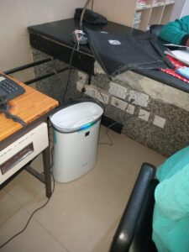
Figure 8.1 Medical applications

2. Institutional
Universities:
Use of HEPA and Carbon systems for R&D labs for reduction/removal ofairborne contaminants and/or pathogens during various phases of the research cycle.
Pre-Schools and Secondary Educational Facilities
: Use of HEPA systems in pre-schools toreduce levels of airborne pathogens and minimize spread of communicable disease.Use ofHEPA systems in High Schools for overall air filtration of occupied areas.
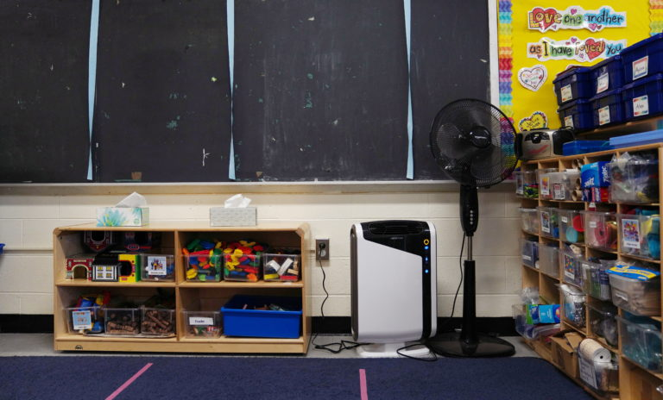
Figure 8.2 Institutional applications

3.Commercial
Household Health and Personal Care Products:
Use of HEPA and Carbon based systemsfor reduction/removal of contaminants associated with the design and development of variouschemical and compound based health care and cosmetic products.
Food Products and Beverages:
Use of HEPA systems to maintain mid-level clean roomenvironment for packaging and processing of food grade products. This includes the bottlingprocess for many alcoholic and non-alcoholic beverages.
Restaurant:
Use of HEPA and Carbon systems for removal of odours and airborneparticulates in food service and various retail facilities. Also used for removal of cigarette andcigar smoke in those bars and restaurants that allow smoking.
Apartments and Hotels:
Use of HEPA systems in apartment complex HVAC systems(where individual air handlers are used) and in high end Hotels for meeting and conference rooms.
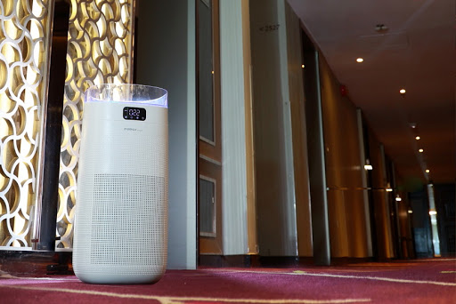
Figure 8.3 Commercial applications

4.Industrial
Microelectronics:
Use of HEPA and Carbon systems in the manufacture of microchips andother dust sensitive electronic components. Typically these types of products have to befabricated in a clean-room type of environment.
Optics:
Use of HEPA systems to maintain clean room environment in the manufacture ofprecision optics for commercial and military use.
Precision Component Manufacturing:
Use of HEPA systems for reduction/removal of finedust generated in the manufacturing of precision components to minimize maintenance issueswith particulate getting into process equipment.
Testing Laboratories:
Use of HEPA systems to remove fine airborne particulate generatedduring various phases of compound testing (i.e. mineral labs, precious metal labs).
Automotive:
Use of HEPA systems in the paint and coatings labs and R & D facilities.
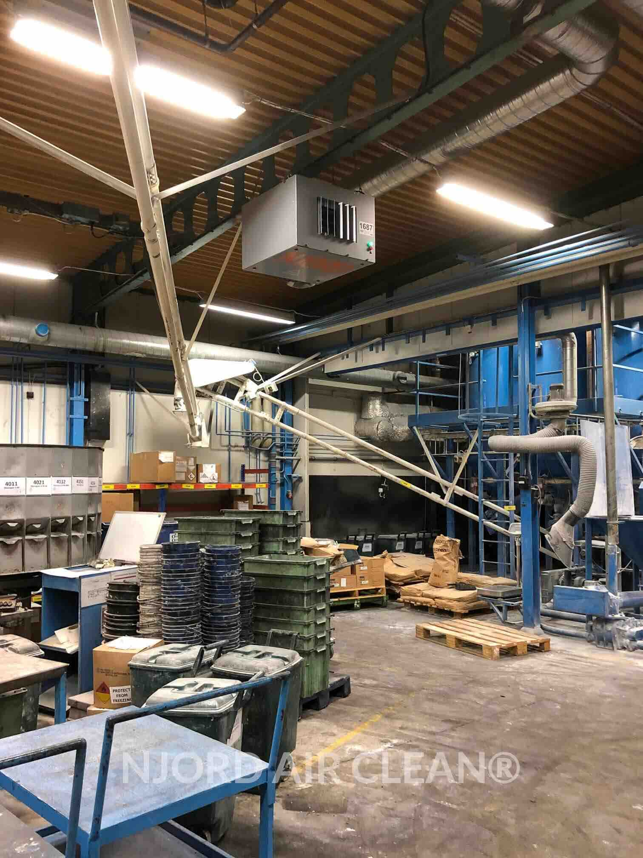
Figure 8.4 Industrial applications

5. Military
Aerospace Guidance Systems
: Use of HEPA systems in the manufacture and assembly ofhighly sophisticated, precision guidance systems for all military aircraft, satellites andunmanned systems. These systems are always assembled in clean room environments.
Chemical and Biological Systems:
Use of HEPA systems for protection of occupants in thedevelopment and testing of certain chemical and biological compounds.
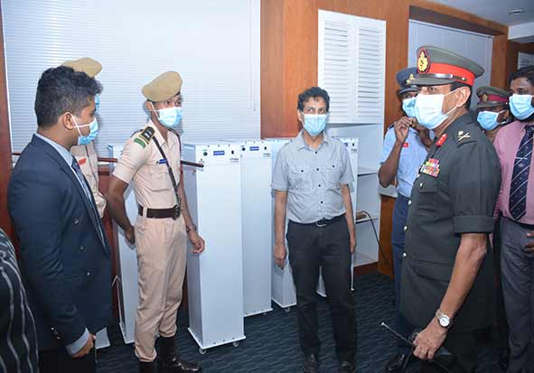
Figure 8.5 Military applications
8.4 Future Scope:
Increase in vehicular population, severe construction activities, and industries are largely contributing to an increase in outdoor pollution across Indian cities. It is quite evident that, with a growing economy and over 125 billion people to feed, the destruction will continue and more forests will be cut and space created for infrastructure. So there will be consequences for these actions. Starting from groundwater, the crops and the air they are all becoming toxic. Obviously, the coming generations will pay heavily for this irresponsible action by us. What we need are consciousness and actions that can at least reduce the burden to the only planet that we have. While most of us have taken control of the food and water intake, but the air we breathe is ignored completely. Respiratory symptoms, especially among children are on the rise which signals in the effects of toxins that are causing severe damage to the respiratory system. It is also evident from the increase in your trips to the doctor or medication. Air pollution is responsible for wheezing, sneezing, cough, asthma, and various other illness including heart attack and lung cancer. Thus, it is important to not just purify the indoor air, but also to avoid the pollutants from entering and keeping the environment clean and pure. In today’s time, air purifiers are as much a necessity as a water purifier.
Several studies, including those of British Allergy Foundation, have proven that breathing air clean and purified by Sharp air purifiers reduce the number of toxins entering our body, thereby decreasing the need for medication or taking days off from work. This is missing from most brand commitments since they are too occupied with reducing dust or other particles and have diverted from the actual need and benefits that a consumer expects. Most people mistake the indoor air to be safe and free from pollution, however, due to poor ventilation and lack of sunlight, each and every activity that we do indoor contributes to adding toxins in the air we breathe. For example kitchen smoke, mosquito repellants, cleaning solutions, and electronic appliances they all contribute equally to poison the air we breathe. Apart from many other methods to reduce the airborne toxins in an indoor space like plants, air purifiers are gradually gaining momentum. However, due to lack of instant gratification or immediate result, the category has still not become popular among consumers. Each consumer, in-spite of their problems, is afraid to take a decision that involves an investment of around 20K or more.
As people’s awareness increases and the demand for air purifiers rises, so does the requirement for advanced technologies. Almost all the leading brands spend a lot of time and resources on the R&D of their product and the air purifier market is expected to witness a rise in the demand of purifiers. At present, technologies such as air purifiers with mosquito catcher, car purifiers, and air sterilizers are already prevailing in the market, but the market for such products is still very small and limited. Currently, most Air Purifiers come with HEPA& Carbon Filters which can provide solution up to an extent and be going forward and as consumer awareness increases demand for higher technology marvels like Plasma cluster Ion Technology will be an accepted standard so as to get holistic solution towards Air Pollution. Also, confused messaging with respect to performance indicators of Air Purifiers i.e. in build Air Quality monitors which are inefficient in capturing complete constituents of Air Pollution and can only provide mental satisfaction to users by providing inconsistent readings (only on PM 2.5 which constitute only 25 percent of Indoor Air Pollution) will see an end. Although the Indian air purifier market is still in its nascent stage, the market has a vast scope, as people are getting aware and conscious about the effects of air pollution on their health, their family, and especially on little kids. Innovations in air purification systems need to be holistically devised to kill bacteria and virus, reduce odours, and remove dust, pollen, and other pollutants from the atmosphere
8.5 Conclusion :
For sustainable development, applying Solar Energy technology which is simple and renewable and that provides us constant supply of electricity; to our air purifier which is used to achieve a better air quality index. In this project, our Solar powered air purifier which can cost less and is highly efficient, which promotes the use of sustainable development and is economical. Also in future, modifications can be made to improve working efficiency without effecting setup.

CHAPTER 9
9.1 BIBLIOGRAPHY

1. http://www.diva-portal.org/smash/get/diva2:1165621/FULLTEXT01.pdf

2. https://www.instructables.com/id/Air-Purifier-With-Variable-Speed-Fan-and-HEPA-Filt/

3. https://www.oransi.com/page/beginners-guide-airpurifier#:~:text=An%20air%20purifier%20is%20made,to%20have%20high%20efficiency%20filters.

4. Air quality monitor: https://www.youtube.com/watch?v=70JTBou1FKM&t=3s

5.Fan : https://www.amazon.in/FourDot-Axial-Computer-CoolingCabinet/dp/B07MQTQWFR/ref=pd_sbs_328_14?_encoding=UTF8&pd_rd_i=B07MQTQWFR&pd_rd _r=3c198e45-f1cd-4190-97a3c1fce546b634&pd_rd_w=hdIUP&pd_rd_wg=eEqkw&pf_rd_p=00b53f5d-d1f8-4708-89df2987ccce05ce&pf_rd_r=2WMD2AG77YMQJPBX5PRN&psc=1&refRID=2WMD2AG77YMQJPBX5P RN

6.https://www.researchgate.net/publication/325485637_Design_and_Fabrication_of_Solar_Powered _Air_Purifier

7.https://www.researchgate.net/publication/325485637_Design_and_Fabrication_of_Solar_Powered_A ir_Purifier

8. National Air Quality Index by Central Pollution Control Board

http://www.indiaenvironmentportal.org.in/files/file/Air%20Quality%20Index.pdf

9. Bates, D.V. (1999).“Introduction” in Air pollution and Health (Eds S.T. Holgate, J.M. Samet, H.S. Koren, R.L.

https://www.citewrite.qut.edu.au/write/litreview.jsp

Maynard). Academic Press, New York.

